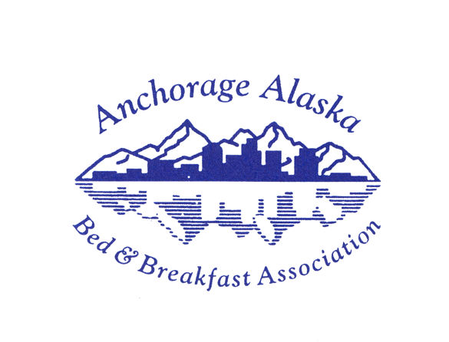 | Becoming an  Inspected & Approved Member B&B  of the AABBA  extend your reach!

Join the AABBA as an member B&B and set your inn apart! Stand out when travelers are considering where to stay during their visits by earning the esteemed “Inspected & Approved” insignia. The AABBA is the Official B&B Association of Anchorage and offers this distinction to Bed & Breakfasts that meet requirements for life safety, hygiene, and business operations.

When you first apply, the AABBA Board confirms your nomination and begins the process of setting up the marketing channels that will bring you to the attention of our visitors and guests. The membership is renewed annually; inspections are scheduled every other year.

- You will be featured on our members page on the AABBA Website
  - Visit www.anchorage-bnb.com and www.facebook.com/AABnBA
  - We encourage guests to post their pictures and memories of their B&B experience so that others know immediately how much they enjoyed their stay.

- You will receive a decal for your door or window announcing that you are AABBA Inspected & Approved –this adds to the visitors’ impression of your professionalism.

- You will have opportunities to develop relationships with our Associate/Travel Partner members who have displays at the AABBA Annual Vendor Fair.
  - Many offer AABBA discounts to AABBA guests or incentives to you
  - You will hob nob with other B&B owners in a friendly atmosphere – a good time to invest in relationships that lead to sharing ideas and solving problems that you never expect to encounter in running a B&B

- You will write for social media (we have a blog, Face Book, LinkedIn, and Pinterest as AABBA), and our B&B hosts pick up the theme for Twitter, Instagram, and their own social media accounts. Back links to your own website are worth $$ for adding to your page rank.

- You will be invited to the AABBA Autumn Celebration at the end of the season. This low-key event gives an opportunity to informally evaluate how our partnership of B&Bs and Associate/Travel Partners affected our businesses and gives us time to take a deep breath!

The AABBA is an association based on professionalism and quality of the Alaska travel experience. B&Bs that apply for membership must undergo a peer review as part of joining, and then again biennially. Only Municipality-registered/Alaska business licensed B&Bs in the Anchorage area are members.
Mary M. Rydesky
Past-President, AABBA
907-227-2393
Host, Jarvi Homestay

Please join us in making great travel memories for our guests
while you enjoy the community of B&B hosts who help
one another succeed through quality standards & mentorship!

