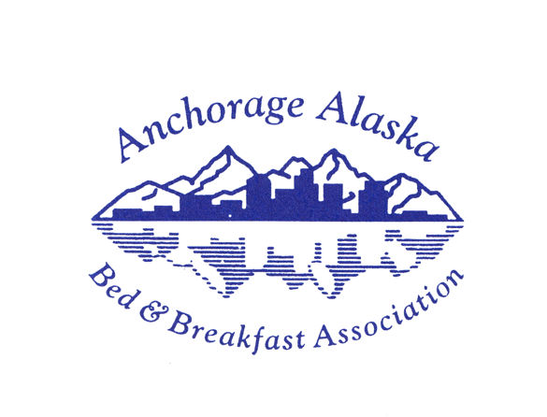 | Becoming an  Associate/Travel Partner  of the AABBA  extend your reach!

The Anchorage Alaska Bed & Breakfast Association hosts want to talk about you over breakfast.
Join the AABBA as an “A/TP” and become the subject of conversation as guests plan their day. B&B hosts are called upon for recommendations, and we love to give references to people we know personally!

The A/TP membership has an annual fee of $95.00. When you first apply, the AABBA Board confirms your nomination and begins the process of setting up the marketing channels that will bring you to the attention of our guests.

- You will be featured on our Travel Partners page on the AABBA Website as well as in the printed Directory that is distributed to each member B&B for guest rooms and coffee table access.
  - Visit www.anchorage-bnb.com and www.facebook.com/AABnBA
  - We encourage guests to post their pictures and memories of your tour, restaurant, or services so that others know immediately how much they enjoyed the day.

- You will receive a decal for your door or window announcing that you are an A/TP – adds to the visitors’ impression of your professionalism.

- You will have a display area at AABBA Vendor Fairs/events at no extra fee. Bring your materials, including rack cards, schedules, and other items that can be given to travelers. Tip: business card-sized discount cards with your reservation web link and phone number are winners!
  - You will hob nob with other A/TPs in a friendly atmosphere – a good time to invest in relationships that lead to more referrals around town.

- You will be written about in social media (we have a blog, Face Book, LinkedIn, and Pinterest as AABBA, and our B&B hosts pick up the theme for Twitter, Instagram, and their own social media accounts. Back links to your own website are worth $$ for adding to your page rank.

The AABBA is an association based on professionalism and quality of the Alaska travel experience. B&Bs that apply for membership must undergo a peer review as part of joining, and then again biennially. Municipality licensing of B&Bs in the Anchorage area is required for membership.
Please join us in making great travel memories for our guests!
Caroline Valentine
President, AABBA

